**East West University**

**Lab Report**

**Semester:** Fall-2024

**Course Title:** Electronic Circuits **Course Code:** CSE251

**Sec:** 03

**Expt No: 02**

**Expt Name: Half-Wave Diode Rectifier Circuit**

**Group No: 07**

**Submitted by-**

**Name: Sheikh Sarafat Hossain**

**Id: 2022-3-60-109**

**Submitted to-**

**Dr. Sarwar Jahan**

**Associate Professor**

Department of Computer Science & Engineering

East West University

**Date of Performance: 07-11-2024**

**Date of Submission: 14-11-2024**

**Objectives of the Experiment:**

The learning objectives of this experiment is related to study half wave rectifier circuit and the effect of a capacitor filter on the output of the rectifier circuit.

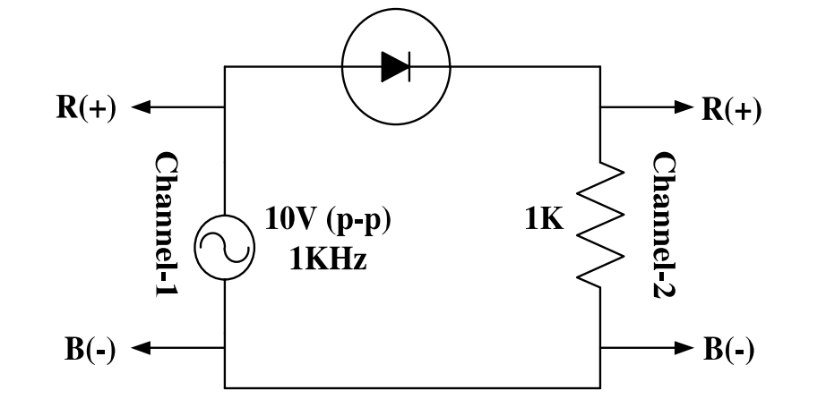**Circuit Diagram:**

$$V_{R}$$

(-)

**Answers to the Pre-Lab Questions:**

1. **Consider the half wave rectifier circuit shown in figure 1.It is fed by a 1.0 KHz sinusoid having a peak value of 5V.Design the circuit (determine the value of the parallel capacitor) so that the output will have a peak-to-peak ripple of $Vr$ =0.5V using the formula $V_{r}=\frac{V_{P}}{fCR}$.Calculate the diode conduction time $Δt$ and conduction angle $ωΔt$ using the formula $ωΔt=\cos^{-1}\left(\frac{V_{p}-V_{r}}{V_{p}}\right)$.Also calculate the average and peak values of the diode currents using the formulas $i_{Davg}$ = $\frac{V_{p}-\frac{V_{r}}{2}}{R}\left(1+π\sqrt{\frac{2V_{P}}{V_{r}}}\right)$ and $i_{Dmax}$ = $\frac{V_{p}-\frac{V_{r}}{2}}{R}\left(1+2π\sqrt{\frac{2V_{P}}{V_{r}}}\right)$.**

**Ans:**

We know, $V_{r}=\frac{V_{P}}{fCR}$

= $\frac{fCR}{V_{p}}=\frac{1}{v_{r}}$

C= $\frac{v_{p}}{v_{r}fR}$

= $\frac{5}{\dot{0.5*1000*1000}}$

=10 $uF$

Conduction angle, $ωΔt$ = $\cos^{-1}\left(\frac{V_{p}-V_{r}}{V_{p}}\right)$

= $\cos^{-1}\left(\frac{5-0.5}{5}\right)$

=25.842 rad

Conduction time, $Δt$ = $\frac{Conduction angle (ωΔt)}{ω}$

=25.842/ $2πf$

=25.842/(2×3.1416×1000)

=4.11 ms

Average diode current,

$i_{Davg}$ = $\frac{V_{p}-\frac{V_{r}}{2}}{R}\left(1+π\sqrt{\frac{2V_{P}}{V_{r}}}\right)$

= $\frac{5-\frac{0.5}{2}}{1000}\left(1+π\sqrt{\frac{2*5}{0.5}}\right)$

=71.48mA

Peak Diode Current, $i_{Dmax}$ = $\frac{V_{p}-\frac{V_{r}}{2}}{R}\left(1+2π\sqrt{\frac{2V_{P}}{V_{r}}}\right)$.

= $\frac{5-\frac{0.5}{2}}{1000}\left(1+2π\sqrt{\frac{2*5}{0.5}}\right)$

=138.22mA

**Answers to the Post-Lab Questions:**

1. **Ans:**

The measured voltage (7.80 V) is more than the expected voltage (5.96 V) in Experiment 1. Differences are normal, but factors like measurement errors or calibration might be involved. Checking instrument accuracy and calibration can help ensure reliable results. The gap is big, further investigation and adjustments might be needed.

1. **Ans:**

The measured ∆t value is 0.16 mS, which is much lower than the prelab value of 4.11 ms. This means there's a significant difference between the expected and actual results. It's important to check for possible errors or factors affecting the measurement accuracy.

1. **Ans:**

From experiment,

$$f=1000 Hz$$

$$V_{P}=10.2 V$$

$$∆t=160 µs=1.6×{10}^{-4} s$$

$$ωΔt=\sqrt{\frac{{2V}_{r}}{V_{p}}}$$

$$or, V_{r}=\frac{{(ωΔt)}^{2}}{2} ×V_{p}$$

$$or, V_{r}=\frac{{(2πfΔt)}^{2}}{2} ×V_{p}$$

$$or, V_{r}=\frac{{(2π×1000×1.6×{10}^{-4})}^{2}}{2} ×10.2$$

$$or, V_{r}=5.15V$$

The calculated ripple voltage was expected to be 5.15 volts, but the measured value turned out to be a tiny 0.5 volts. It's like anticipating a big wave but getting a gentle ripple. Differences between theory and reality can happen due to component variations, circuit conditions, or unforeseen factors.

1. **Ans:**

From experiment,

$$V_{p}=10.2V$$

$V_{r}=480 mV=0.48 V$

Average output voltage,

$$V_{0}=V_{p}-\frac{V_{r}}{2}$$

$$=10.2-\frac{0.48}{2}$$

$$= 9.96 V$$

1. **Ans:**

From “4” we get,

$$V_{0}=9.96 V$$

$$V_{p}=10.2V$$

$V_{r}=480 mV=0.48 V$

$$R=1KΩ=1000Ω$$

Given that,

$$I_{L}=\frac{V_{0}}{R}$$

$$= \frac{9.96}{1000}$$

$$=9.96×{10}^{-3}A$$

Average diode current,

$i_{Davg}$ = $I_{L}\left(1+π\sqrt{\frac{2V_{P}}{V_{r}}}\right)$

$$= 9.96×{10}^{-3} ×\left(1+π\sqrt{\frac{2×10.2}{0.48}}\right)$$

$$=0.213 A$$

$$=213 mA$$

Max Diode Current, $i_{Dmax}$ = $I_{L}\left(1+2π\sqrt{\frac{2V_{P}}{V_{r}}}\right)$

$$=3.12×{10}^{-3} ×\left(1+2π\sqrt{\frac{2×10.2}{0.48}}\right)$$

$=417.9 mA$

The average current calculated is 213 mA, with a maximum of $417.9$ mA. The pre-lab values were 71.48 mA and 138.22 mA. Although calculations may be slightly off, the real-world values are close friends with theoretical ones. The currents are in the same ballpark, but not quite, which is acceptable in circuits and currents.

**Discussion:**

